**NASA Promise Dataset Software Reliability**

*A FISAC Report Submitted to*

**MANIPAL ACADEMY OF HIGHER EDUCATION**

*For Partial Fulfillment of the Requirement for the of the Degree*

*Of*

**Bachelor of Technology**

*by*

**Rishabh, Swapnil, Pranathi**

**210953080, 21095311292, 210911290**

Under the guidance of

|  |  |
| --- | --- |
| Ms. Anuradha Rao  Assistant Professor Senior-Scale |  |
| Department of I&CT |  |
| Manipal Institute of Technology |  |
| Manipal, Karnataka, India |  |



**5th November 2024**

1. Demonstrate various software reliability models(JM, NHPP, Littlewood Verall, Weibull) for failure intensity rate, mtbf and reliability/availability with randomly generated failure data/downloaded failure data from open repository.

Dataset Chosen – **NASA Promise Dataset**

<https://github.com/ApoorvaKrisna/NASA-promise-dataset-repository>

1. Use prediction models (consider mean of 2 previous failures, 3 previous failures, 4 previous failures, calculate u-values for each. Tabulate

1. Use Kolmogorov Smirnov test to evaluate.

**Code Snippet**

**Output**

1. Use the least square method and maximum likelihood method the estimate the parameters.

1. Use Prequential method. Select the best fitting model.

1. Improve the accuracy by choosing any techniques – recalibration, grouping, optimum data selection etc.

1. Develop an operational profile and decide on test cases, make the budgeting required for testing and maintenance.

1. Do the reliability testing – use any approaches used – regression – test retest, retest all etc..

We used the approach of **test-retest** using **Regression Testing**

1. Develop Markov Model and get the results with to optimize the no.of. test cases

1. Based on the application mention the certification bodies and get the certification.

1. Make a risk analysis and develop a risk matrix.

1. Mention internal and external attributes. Calculate the size, function point count, cyclomatic complexity number, Halstead’s numeric, system cohesion & coupling, object oriented metric whichever applicable.

Metrics used are: **Cohesion-Coupling and Cyclometric Complexities**

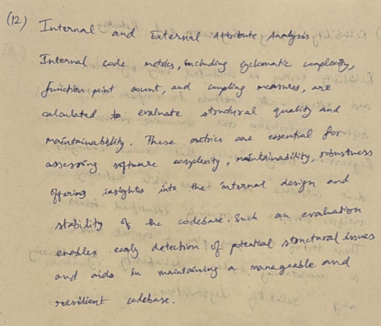

1. Develop a GQM tree for maintainability.

1. Write about the various quality models.

**CONCLUDING REMARKS**

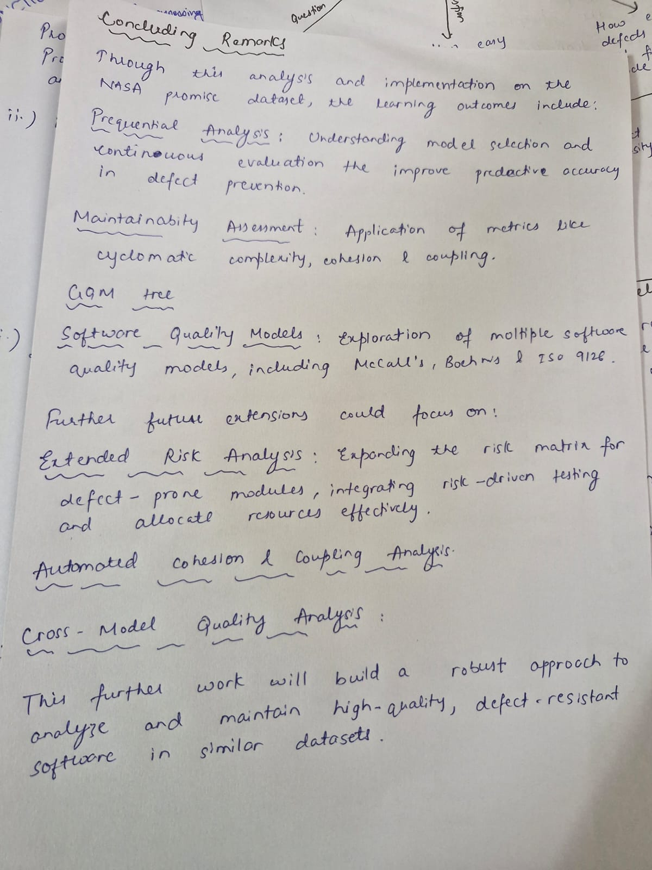

**CONTRIBUTIONS**

**CODE REPOSITORY**

* Code used in this document is maintained and stored efficiently. Refer to the link below to access:

[**https://github.com/RampageousRJ/NASA-Promise-Dataset-SRE-FISAC**](https://github.com/RampageousRJ/NASA-Promise-Dataset-SRE-FISAC)

* Find the open source accessible dataset here:

[**https://github.com/ApoorvaKrisna/NASA-promise-dataset-repository**](https://github.com/ApoorvaKrisna/NASA-promise-dataset-repository)